ENTERPRISE ARCHITECTURE

Advisor Portfolio Rebalancing & Suitability Review Platform
Low-Level Design (LLD)

Architecture Design Document
Document Version | 1.0
Date | 10 June 2025
Status | Draft
Classification | Confidential
Prepared By | Generated by Design Document Generator
Reviewed By | Enterprise Architecture Review Board

Document Control
This document provides the authoritative architecture design specification for the project. It is intended for consumption by architects, technical leads, and senior developers.

Version History

Version | Date | Author | Description
1.0 | 10 June 2025 | Generated by Design Document Generator | Initial release

Table of Contents
Note: Update this table of contents after opening the document in Microsoft Word (References → Update Table).

1. Low-Level Design (LLD)
1.1 API Design
1.2 Database Design & Entity Model
1.3 Security & Authentication Design
1.4 Sequence Diagrams
1.5 Error Handling Strategy
1.6 Logging & Observability
1.7 Caching Strategy
2. Recommended Technology Stack
3. Security & Deployment Architecture
4. Risks, Open Questions & Dependencies

1. Low-Level Design (LLD)

1.1 API Design
RESTful API design with resource-oriented endpoints, stateless JWT authentication, URL-based versioning, and consistent error handling (RFC 7807). All endpoints require authentication and enforce RBAC. Errors return HTTP status codes and structured error objects. Rate limiting is enforced at the gateway.
Base URL: /api/v1
Authentication: JWT Bearer Token issued via SSO (OIDC/SAML) and validated on each request. MFA enforced for privileged roles. All endpoints require Authorization header.
Versioning: URL versioning: all endpoints prefixed with /api/v1. Future breaking changes increment version in URL.

API Endpoints

Method | Path | Description | Authentication | Rate Limit
POST | /auth/login | Initiate SSO login and obtain JWT token. | SSO (SAML/OIDC) required | 20 req/min per user
GET | /portfolios | List all portfolios assigned to the authenticated advisor. | JWT Bearer (Advisor role) | 60 req/min per user
GET | /portfolios/{clientId} | Get detailed holdings and profile for a client. | JWT Bearer (Advisor role) | 60 req/min per user
POST | /proposals | Create a new rebalancing proposal for a client. | JWT Bearer (Advisor role) | 30 req/min per user
PUT | /proposals/{proposalId} | Edit or update a draft proposal. | JWT Bearer (Advisor role) | 30 req/min per user
POST | /proposals/{proposalId}/submit | Submit proposal for suitability validation and compliance review. | JWT Bearer (Advisor role) | 20 req/min per user
GET | /proposals/{proposalId}/validation | Get suitability validation report for a proposal. | JWT Bearer (Advisor/Compliance) | 30 req/min per user
POST | /proposals/{proposalId}/approve | Approve a proposal (Compliance Officer only). | JWT Bearer (Compliance role, MFA) | 20 req/min per user
POST | /proposals/{proposalId}/reject | Reject a proposal with mandatory comment. | JWT Bearer (Compliance role, MFA) | 20 req/min per user
GET | /audit | Search and filter audit log entries. | JWT Bearer (Compliance/Admin) | 30 req/min per user
POST | /ai/summary | Generate AI-assisted client summary for a proposal. | JWT Bearer (Advisor role) | 10 req/min per user

1.2 Database Design & Entity Model
Relational database (PostgreSQL 15) with normalized schema for users, clients, portfolios, proposals, versions, rules, and audit logs. Partitioning by client_id for scalability. Indexes on proposal_id, client_id, and timestamps. Attachments stored in object storage with DB pointers.
Database Type: Relational (PostgreSQL)

Entity Relationships
Each User can be assigned to multiple ClientProfiles. Each ClientProfile has multiple PortfolioHoldings and Proposals. Each Proposal has multiple ProposalVersions and one or more SuitabilityValidationReports. ComplianceRules are referenced by the Suitability Engine. AuditLogEntry records all actions by users on proposals, rules, and user accounts.

User
System user account with RBAC and SSO linkage.
Attribute | Type | Description | Constraints
user_id | UUID | Primary key | PRIMARY KEY
full_name | VARCHAR(100) | User's full name | NOT NULL
email | VARCHAR(255) | Unique email address | NOT NULL, UNIQUE
role | VARCHAR(32) | User role (Advisor, Compliance, etc.) | NOT NULL
is_active | BOOLEAN | Active status | DEFAULT true
sso_provider_id | VARCHAR(128) | SSO identity provider ID
mfa_enabled | BOOLEAN | MFA enabled flag | DEFAULT false
created_at | TIMESTAMP | Creation timestamp | NOT NULL
last_login_at | TIMESTAMP | Last login timestamp

ClientProfile
Client profile and investment preferences.
Attribute | Type | Description | Constraints
client_id | UUID | Primary key | PRIMARY KEY
full_name | VARCHAR(100) | Client name | NOT NULL
risk_profile | VARCHAR(32) | Risk profile enum | NOT NULL
investment_goals | TEXT | Goals
time_horizon | INTEGER | Investment horizon (years)
assigned_advisor_id | UUID | FK to User | FK → User.user_id
created_at | TIMESTAMP | Created | NOT NULL
updated_at | TIMESTAMP | Updated

PortfolioHolding
Individual asset holdings for a client.
Attribute | Type | Description | Constraints
holding_id | UUID | Primary key | PRIMARY KEY
client_id | UUID | FK to ClientProfile | FK → ClientProfile.client_id
asset_class | VARCHAR(64) | Asset class
security_name | VARCHAR(128) | Security name
ticker | VARCHAR(16) | Ticker symbol
quantity | DECIMAL(18,4) | Units held
current_value | DECIMAL(18,2) | Market value
current_allocation_pct | DECIMAL(5,2) | Current allocation %
target_allocation_pct | DECIMAL(5,2) | Target allocation %
as_of_date | DATE | Valuation date

Proposal
Rebalancing proposal for a client.
Attribute | Type | Description | Constraints
proposal_id | VARCHAR(32) | Unique proposal ID | PRIMARY KEY, UNIQUE
client_id | UUID | FK to ClientProfile | FK → ClientProfile.client_id
advisor_id | UUID | FK to User | FK → User.user_id
status | VARCHAR(32) | Workflow status | NOT NULL
version | INTEGER | Current version | NOT NULL
created_at | TIMESTAMP | Created | NOT NULL
submitted_at | TIMESTAMP | Submitted
resolved_at | TIMESTAMP | Approved/Rejected
notes | TEXT | Advisor notes
suitability_result | JSONB | Validation report

ProposalVersion
Immutable snapshot of a proposal at each save or state change.
Attribute | Type | Description | Constraints
version_id | UUID | Primary key | PRIMARY KEY
proposal_id | VARCHAR(32) | FK to Proposal | FK → Proposal.proposal_id
version_number | INTEGER | Version number | NOT NULL
allocations_snapshot | JSONB | Asset allocations | NOT NULL
saved_by | UUID | User who saved | FK → User.user_id
saved_at | TIMESTAMP | Save timestamp | NOT NULL

SuitabilityValidationReport
Result of suitability validation for a proposal version.
Attribute | Type | Description | Constraints
report_id | UUID | Primary key | PRIMARY KEY
proposal_id | VARCHAR(32) | FK to Proposal | FK → Proposal.proposal_id
version_id | UUID | FK to ProposalVersion | FK → ProposalVersion.version_id
run_at | TIMESTAMP | Validation time | NOT NULL
overall_result | VARCHAR(32) | Pass/Fail/Warning | NOT NULL
violations | JSONB | List of violations

ComplianceRule
Configurable suitability rule.
Attribute | Type | Description | Constraints
rule_id | UUID | Primary key | PRIMARY KEY
rule_name | VARCHAR(128) | Rule name | NOT NULL
risk_profile_target | VARCHAR(32) | Target risk profile
asset_class | VARCHAR(64) | Asset class
operator | VARCHAR(8) | Comparison operator
threshold_pct | DECIMAL(5,2) | Threshold %
severity | VARCHAR(16) | Critical/Warning | NOT NULL
is_active | BOOLEAN | Active flag | DEFAULT true
modified_by | UUID | User who modified | FK → User.user_id
modified_at | TIMESTAMP | Modification time | NOT NULL

AuditLogEntry
Immutable audit trail of all actions.
Attribute | Type | Description | Constraints
log_id | UUID | Primary key | PRIMARY KEY
timestamp_utc | TIMESTAMP | UTC timestamp | NOT NULL
user_id | UUID | FK to User | FK → User.user_id
user_role | VARCHAR(32) | Role at time of action
action_type | VARCHAR(64) | Action performed | NOT NULL
entity_type | VARCHAR(64) | Entity affected
entity_id | VARCHAR(64) | Entity ID
previous_state | VARCHAR(64) | Previous state
new_state | VARCHAR(64) | New state
source_ip | VARCHAR(45) | Source IP address
session_id | VARCHAR(64) | Session ID

Entity Relationship Diagram
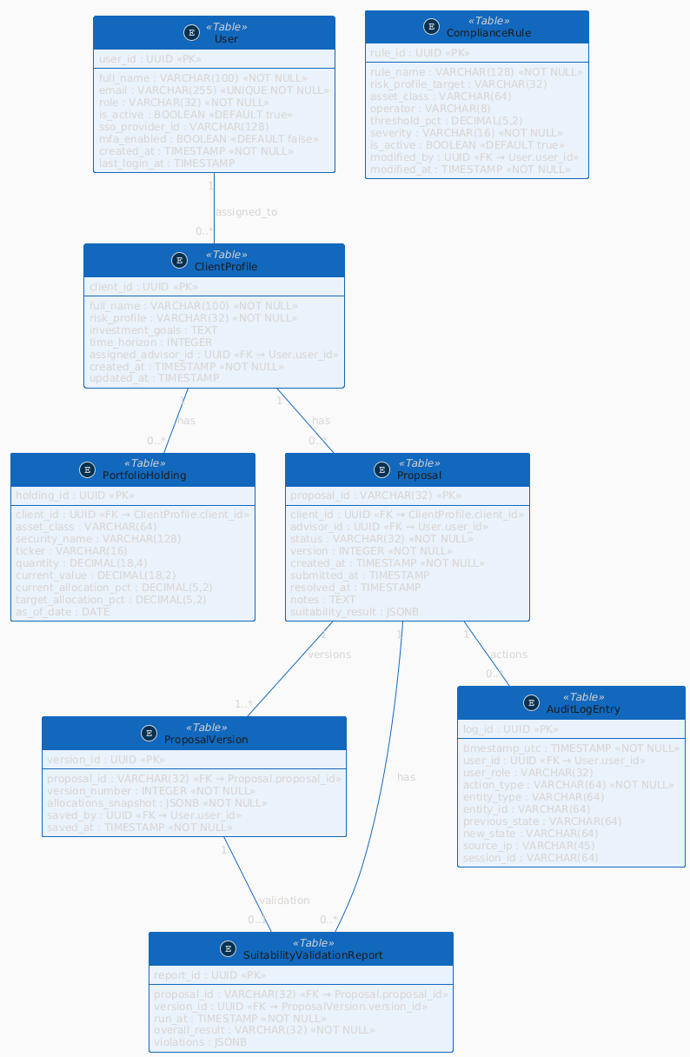
Figure: Entity Relationship Diagram

1.3 Security & Authentication Design
Authentication: SSO via SAML 2.0 or OIDC (OAuth 2.0), with JWT Bearer tokens for API access. MFA enforced for Compliance and Admin roles. Session expiration after 30 minutes inactivity, with warning at 28 minutes.
Authorisation Model: Role-Based Access Control (RBAC) with four roles: Financial Advisor, Compliance Officer, Operations, System Admin. Each role has a defined, non-overlapping permission set. All endpoints check JWT claims for role and permissions.
Data Encryption: All data at rest encrypted with AES-256 (PostgreSQL TDE, S3 SSE). All data in transit encrypted with TLS 1.3. No plaintext PII stored.
Network Security: WAF with OWASP ruleset, DDoS protection, private subnets for data tier, firewall rules restricting access, VPN for admin access, no public DB endpoints.

Security Controls
- OWASP Top 10 mitigations
- Input validation and sanitization on all user input
- CSRF protection for all state-changing endpoints
- XSS protection via frontend encoding and CSP
- Strict RBAC enforcement at API and UI layers
- Audit logging of all privileged actions
- Rate limiting and brute-force protection at gateway
- Secrets management via Key Vault
- Regular vulnerability scanning and patching
- Automated session expiration and revocation
- MFA for privileged roles
- Encryption of all sensitive data at rest and in transit

Compliance Standards
- GDPR
- ISO 27001
- SOC 2 Type II

1.4 Sequence Diagrams

1. User Authentication Flow
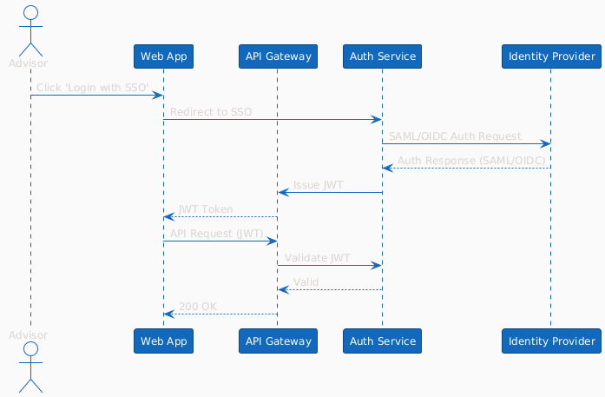
Figure: User Authentication Flow

2. Core Business Flow
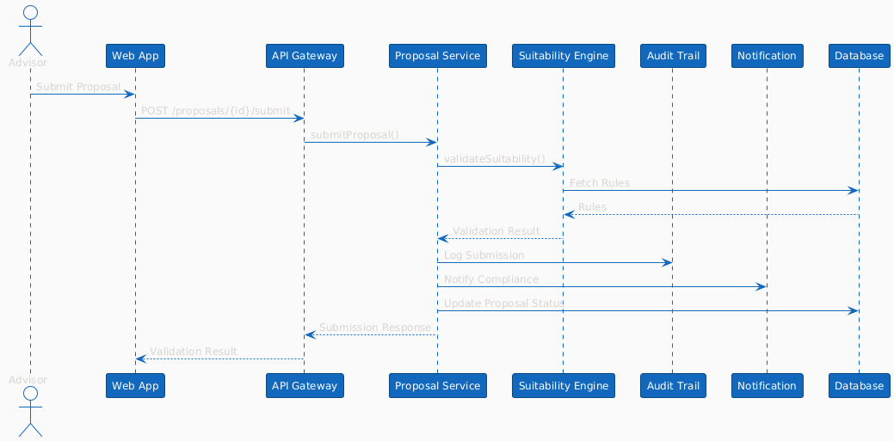
Figure: Core Business Flow

3. Error Handling and Retry Flow
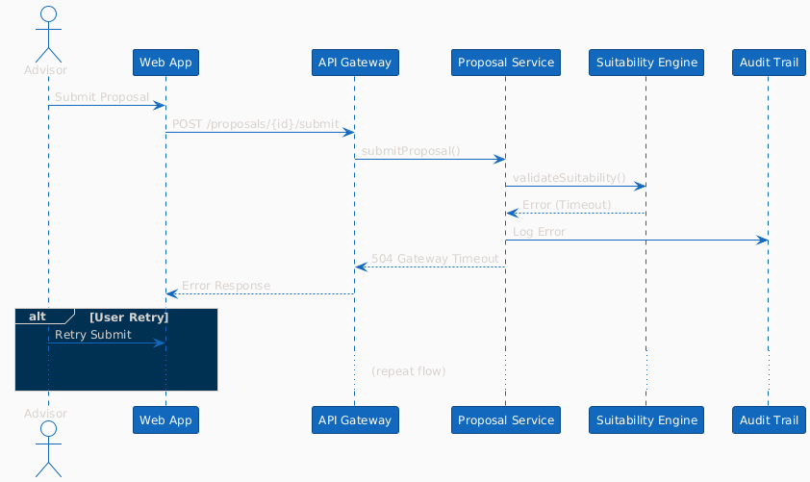
Figure: Error Handling and Retry Flow

1.5 Error Handling Strategy
All API errors return RFC 7807 Problem Details objects. User-facing errors are actionable and non-technical. Retry logic for transient errors (e.g., AI summary, validation) with exponential backoff. Circuit breakers on external integrations. Dead-letter queue for failed notifications. All errors logged with correlation IDs.

1.6 Logging & Observability
Structured JSON logging at all layers. Log levels: ERROR, WARN, INFO, DEBUG. Correlation IDs propagated via headers. Logs retained for 90 days (app), 7 years (audit). Integrated with SIEM (Azure Monitor/Grafana). Sensitive data redacted.

1.7 Caching Strategy
Redis L1 cache for portfolio/proposal reads (TTL 5 min). L2 cache for suitability rules (TTL 1 hour). Cache invalidation on proposal update or rule change. No caching of PII in browser/local storage.

2. Recommended Technology Stack
The following technology stack is recommended based on the analysed requirements, industry best practices, and enterprise standards.

5.1 Frontend
Technology | Version | Purpose | Rationale
React | 18 | SPA frontend | Modern, component-based, widely adopted
TypeScript | 5.x | Type safety | Reduces runtime errors
Material UI | 5.x | UI components | Consistent, accessible UI

5.2 Backend
Technology | Version | Purpose | Rationale
Node.js | 20.x | API and services | Scalable, async, large ecosystem
Express | 4.x | REST API framework | Lightweight, flexible
TypeORM | 0.3.x | ORM | Type-safe DB access

5.3 Database
Technology | Version | Purpose | Rationale
PostgreSQL | 15 | Relational data store | ACID, strong consistency, compliance

5.4 Messaging
Technology | Version | Purpose | Rationale
Redis | 7 | Cache, pub/sub | Low-latency caching, ephemeral data

5.5 Infrastructure
Technology | Version | Purpose | Rationale
Kubernetes (AKS/EKS) | 1.29 | Container orchestration | Scalability, HA, cloud-native
NGINX/Kong | 3.x | API gateway | Security, routing, rate limiting
Azure Blob/AWS S3 | N/A | Object storage | Durable, encrypted file storage

5.6 DevOps & CI/CD
Technology | Version | Purpose | Rationale
GitHub Actions | N/A | CI/CD pipeline | Automation, integration
Docker | 24.x | Containerization | Portability, reproducibility

5.7 Monitoring & Observability
Technology | Version | Purpose | Rationale
Azure Monitor | N/A | Metrics/logs | Cloud-native, alerting
Grafana | 10.x | Dashboards | Visualization, observability

5.8 Security
Technology | Version | Purpose | Rationale
Azure Key Vault | N/A | Secrets management | Centralized, auditable
OWASP CRS | 3.x | WAF ruleset | Mitigate common web threats

3. Security & Deployment Architecture

3.1 Deployment Architecture
The platform is deployed on a cloud-native Kubernetes cluster (AKS/EKS) in a primary region, with a standby DR region for failover. All ingress passes through a managed load balancer with WAF and DDoS protection. Application pods are deployed in private subnets, with network policies restricting east-west traffic. Data tier (PostgreSQL, Redis, Blob) is isolated in a private subnet with no public endpoints. Secrets are managed via Azure Key Vault. Monitoring and logging are centralized. High availability is achieved via multi-AZ deployments, auto-scaling, and health probes. All traffic is encrypted (TLS 1.3). Disaster recovery is enabled via geo-replication and automated backups. The architecture supports horizontal scaling and zero-downtime deployments.

3.2 Deployment Diagram
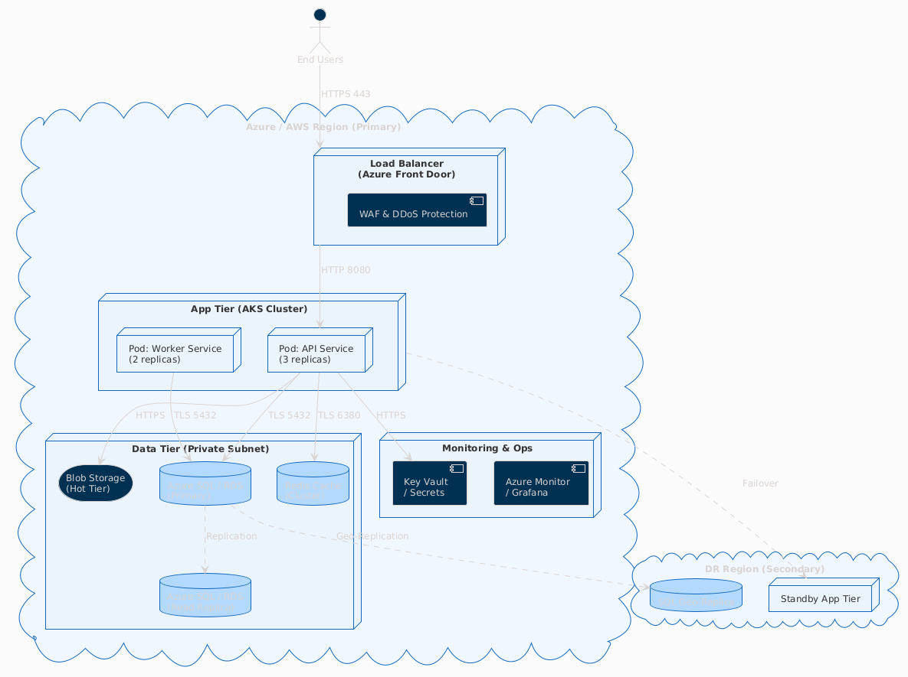
Figure: Deployment Architecture

3.3 Environment Strategy
Environment | Description | Infrastructure | URL
Development | Dev/test environment with seeded data, relaxed security, and debug logging. | Cloud (AKS/EKS, small nodes) | dev.example.com
Staging | Pre-production, full NFRs, production-like data and security. | Cloud (AKS/EKS, medium nodes) | staging.example.com
Production | Live environment, full HA, DR, and compliance controls. | Cloud (AKS/EKS, multi-AZ, HPA) | example.com

3.4 Containerisation & Orchestration
Containerisation: All services packaged as Docker images. Multi-stage builds for minimal images. Images stored in private registry (ACR/ECR). Base images are official Node.js/Alpine, scanned for vulnerabilities.
Orchestration: Kubernetes namespaces per environment. Resource quotas and limits per pod. HPA for API and worker pods. Pod disruption budgets for HA. Rolling updates and blue/green deployments.

3.5 CI/CD Pipeline
Pipeline: code commit → static analysis → unit tests → build Docker image → integration tests → security scan → deploy to staging → E2E tests → manual approval → production deploy.

3.6 Scalability & Performance
Scalability Strategy: Horizontal scaling via HPA. Load balancer distributes traffic. Redis for caching. CDN for static assets. DB read replicas for reporting.
Performance Considerations: SLA: 95th percentile API <500ms, page load <3s. Load testing with JMeter. Bottlenecks mitigated via caching, DB indexing, async processing.

3.7 Disaster Recovery
RTO: 4 hours, RPO: 15 minutes. Automated DB and blob backups. Geo-replication to DR region. Failover tested quarterly.

3.8 Security Measures
- TLS 1.3 everywhere
- WAF with OWASP ruleset
- Secrets management (Azure Key Vault)
- MFA for privileged roles
- RBAC at API and cluster level
- Private subnets for data tier
- No public DB endpoints
- Audit logging of all privileged actions
- Automated vulnerability scanning
- DDoS protection at edge
- Session expiration and revocation
- Regular penetration testing

4. Risks, Open Questions & Dependencies
The following risks, open questions, and dependencies have been identified. All items should be tracked and resolved before the design is finalised.

ID | Category | Description | Impact | Probability | Mitigation | Owner
R1 | Risk | Mock data may not reflect real portfolio complexity, limiting suitability engine validation. | High | Medium | Define representative mock data; review with compliance. | Product Owner
R2 | Risk | Simplified compliance rules engine may not capture all regulatory nuances. | High | High | Document simplifications; plan Phase 2 upgrade; compliance sign-off. | Compliance Officer
R3 | Risk | AI summary quality may be inconsistent for edge-case portfolios. | Medium | Medium | Human editing step; prompt engineering; track edit rates. | Product Owner
R4 | Dependency | SSO integration delays with firm's IdP may block end-to-end testing. | High | Medium | Implement local login fallback for non-prod; engage IdP team early. | Tech Lead
R5 | Risk | Audit log volume may exceed storage projections at scale. | Medium | Low | Size storage for 7 years; implement archiving for logs >1 year. | DevOps
R6 | Risk | Scope creep from stakeholders requesting real-time market data during MVP. | Medium | High | Maintain out-of-scope list; formal change control. | Product Manager

